AS4 thoughts for PEPPOL

Author: Philip Helger, BRZ, Austria

# Introduction

PEPPOL is most likely switching from AS2 to AS4 and this document contains some general thoughts on it.

PEPPOL conceptually builds on the so called “4-corner model” and handles the business document exchange between corner 2 (C2) and corner 3 (C3). Corner 1 (original sender; C1) and Corner 4 (final receiver; C4) are out of scope of PEPPOL document exchange.

# AS2

The AS2 solution is using the following features:

* Basically an S/MIME message
* Requires https transport (transport level encryption) – using non-PEPPOL certificates (!)
* Business documents (UBL/XML) are wrapped in SBDH (Standard Business Document Header)
* AS2 transmissions are signed with the PEPPOL AP certificates

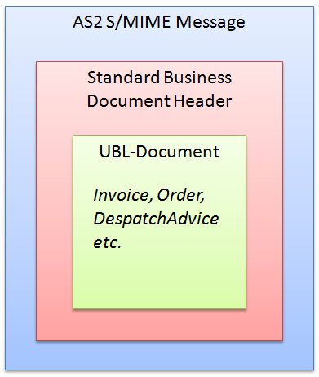

# AS4

AS4 messages can be presented as SOAP messages with a single SOAP body or as MIME messages containing SOAP messages without a body (SOAP with attachments).

Message exchange patterns (MEP bindings) can be one of the following: push, pull, sync, push-push, push-pull, pull-push

# PEPPOL requirements

This chapter contains some thoughts on which AS4 design decisions might apply to PEPPOL in the future. This is work in progress and is not yet a final state!

## Document exchange choreography

The basic choreographies don’t consider MLR and/or BLR. See chapter 4.1.1 for details concerning MLR/BLR.

For a simple document exchange (as e.g. performed when using BIS 4A – Invoice only) the simple AS4 “one way” “push” MEP binding should be sufficient.

For more complex scenarios (like tenders) a “two way” message exchange may be needed but that needs to be defined (I simply don’t know).

### Thoughts on “pull”

Using the AS4 “pull” MEP binding might be an option for all PEPPOL service providers still using the old (and deprecated) PEPPOL LIME (Lightweight Message Exchange) protocol.

I think it would be beneficial to specify a “pull” based protocol and let it be implemented on a voluntary basis.

### Correlation with MLR and BLR

MLR = Message Level Response (validation results)

BLR = Business Level Response (business level validation results)

We would need something like “push-push-push”:

* C2 🡪 C3 Document
* C3 🡪 C2 MLR (optional)
* C3 🡪 C2 BLR (optional)

Alternatively a “sync-push” MEP binding could be invented so that the first “sync” is the main document exchange as well as the (synchronous) MLR and the second “push” would be the optional BLR. The drawback is, that this would require a) a new MEP binding and b) a synchronous MLR.

## PMode considerations

A PMode (processing mode) defines the rules for document exchange between two parties. Usually PModes are configured statically between partners but in PEPPOL this needs to happen dynamically, as PEPPOL document exchange is per se dynamically and the big advantage is, that document exchange can happen without prior knowledge about all the potentially document exchange partners. That implies that a PEPPOL compliant AS4 solution must be able to dynamically create PModes on the fly while operating. More details on how SMP and PMode are correlated can be found in chapter 4.3.

It is recommended that each PMode that is dynamically created receives an ID that is a combination of the CN of the sender and the CN of the receiver separated by a dash (‘-‘). The “CN” is the “subject common name” part of the PEPPOL AP certificate (for example “APP_1000000101”). So if “APP_1000000101” is sending to “APP_1000000202” the created PMode ID should be “APP_1000000101-APP_1000000202”.

The determination of the PMode on sender and/or receiver side is based on 2 possibilities:

* Using special PMode Identifiers
  + This may work in scenarios where ...
* Using a special combination of “service” and “action”
  + Better but duplicates...

So any C3 receiving a document from an ...

## SMP considerations

The SMP (Service Metadata Publisher) is the PEPPOL way to dynamically discover capabilities of partners. Currently an SMP contains only the information about receivers but this may change in the future. Some elements of an SMP query response (a so called “Endpoint”, based on the quadruple of participant ID, document type ID, process ID and transport profile) contains information that must be dynamically fed into a PMode:

* Endpoint URL (e.g. <https://test.e-rechnung.gv.at/as4>)
* The PEPPOL AP certificate (Base64 DER/PEM encoded)
  + The CN of this certificate is part of the PMode ID (see above)

Additionally the following elements of an SMP response must be taken into account

* Service activation and expiration date

The transport profile to be used is

bdxr-transport-ebms3-as4-v1p0

SMP information may change (endpoint URLs and or certificates) so AS4 software must be able to update existing PModes (if they are persistent).

# Mail Jose

Trust and Security Concerns in Message Reception

The certificate that signed the message might not be known beforehand, so it is not in the trust store. An option is that the message contains the certificate and preferably the complete cert path. In that case the AS4 gateway might only need to contain the root CA certificate in its trust store to be able to validate the signature. Certificate recognition on incoming messages will still use certificate CN as APP and CA verification chain against OpenPeppol CA?

Also if you could point me to what you consider the most controversial points to discuss in AS4 Peppol profile I can read and extract conclusions for next meeting.